|  |  |  |  |
| --- | --- | --- | --- |
| Name |  | Date |  |
| Objective | | | |
| Complete the equation for each wire below. | | | |

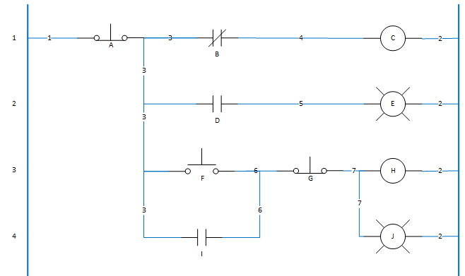

Wire 3 = _________________________________________

Wire 4 = _________________________________________

Wire 5 = _________________________________________

Wire 6 = _________________________________________

Wire 7 = _________________________________________